GetAhead - Interview Practice 6

Car Plates Vocabulary

We need to find the shortest word from a vocabulary that includes **all** the letters from a given licence plate. The shorter the word, the better. The licence plates start with two or three letters, then they are followed by 5 characters, from which at most 2 are letters, the rest are digits.

Write a solution that will find the shortest words for 1000 licence plates.

You are given a vocabulary containing all valid words.

* Keep duplicate letters
* Ordering is irrelevant
* Case is irrelevant
* The vocabulary is sorted lexicographically
* The vocabulary contains about 4 million entries

**Example**:

For the licence plate RT 123SO the shortest word would be SORT:

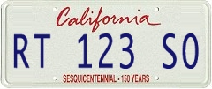

for RC 10014 the shortest word would be CAR.

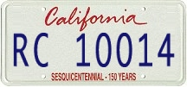

## Submission Instructions

The due date for this question is: Sunday, June 30 11:59pm BST

**When you are confident about your solution, please follow these two steps to submit your solution:**

1 - **Create a new document in Google Drive**, copy and paste your code in it. If you found something particularly challenging, or if you have any questions, feel free to add those to the document as comments.

2 - When done, click on the "**Turn In**" button.